Immunization Dashboard

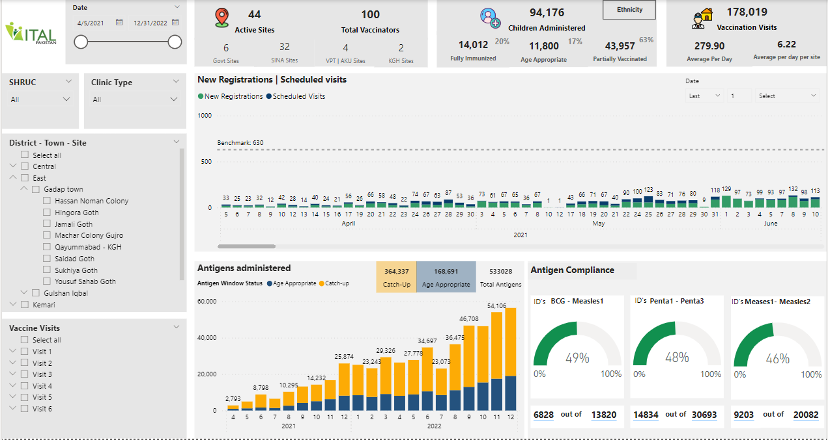

Database and Tables
The database is SQL and below is the list of tables used for data uploading in Power BI
- [Company_TARGET]. vr.child_registration
- [Company_TARGET].vr.loc_str
- [Company_TARGET].Vr.client
- [Company_TARGET].vr.log_death_child
Queries and Data Load:
Query log sheet_updated - Contains information on all queries made by company, their names, their descriptions, activity status etc.
Details of server which is used to pull data from postgres are mentioned below:

Data Modelling:
The detail of data modeling is given below:

From: Table (Column Name) | To: Table (Column Name) | Cardinality | Cross Filter Direction
Visits (Date) | Calendar Table (Date) | Many to One | Single
Visits (Location) | Location Master Table (Location) | Many to One | Single
KHI Clinic Data (Location) | Location Master Table (Location) | Many to One | Single
Compliance Table (Location) | Location Master Table (Location) | Many to One | Single
Compliance Table-Non-compliance VRIDs (Location) | Location Master Table (Location) | Many to One | Single
Visits (Vaccine) | Dim-IS (Vacc) | Many to One | Single

Slicers:
There is five slicers used in the dashboard and details are given below:
- Date slicer is applied from the Calendar table and the Date column is used in the slicer.
- Clinic Type slicer is applied from the Location Master table and the Clinic Type column is used in the slicer.
- SHRUC slicer is applied from the Location Master table and the SHRUC column is used in the slicer.
- District - Town - Site slicer is applied from the Location Master table and the District - Town - Site column is used in the slicer.
- Vaccine Visits slicer is applied from the Location Master table and the Vaccine and num groups columns are used in the slicer.
Filter:
Only one filter is applied on the page level i.e the Date is after 4 April,2021.
Bookmarks:
There are two bookmarks that have been created mainly for the purpose of showing the average number of visits per day and average number of visits per day per site.
- Overall Average
- Last 30 days Average

Visuals

1. Visual # 1(Active sites and total vaccines)

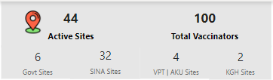

Description:
This visual shows the total number of sites active along with the total vaccinators which is a static number right now. At the same time, the breakdown of different sites has also been shown.
DAX / Measure:
Active Sites = CALCULATE(DISTINCTCOUNT(Visits[Location]),'Visits'[Clinic Type]<>BLANK())
Total Vaccinators = CALCULATE(100,'KHI Clinic Data'[VACC - ID's]="Vacc")
Govt Sites = CALCULATE(DISTINCTCOUNT('Visits'[Location]),'Location Master Table'[CLINIC TYPE]="Govt.")
SINA Sites = CALCULATE(DISTINCTCOUNT('Visits'[Location]),'Visits'[Clinic Type]="SINA")
VPT | AKU Sites = CALCULATE(DISTINCTCOUNT('Visits'[Location]),'Visits'[Clinic Type]="VPT | AKU")
KGH Sites = CALCULATE(DISTINCTCOUNT('Visits'[Location]),'Visits'[Clinic Type]="KGH")

Filters:
No filter has been applied.

2. Visual # 2 (Children administered)
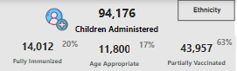
Description:
This visual shows the total number of children administered under the age of 2 years along with its breakdown in terms of the number of children being fully or partially vaccinated or age appropriate with their percentages.
DAX / Measure:
Children Administered = CALCULATE(DISTINCTCOUNT(Visits[baseentityid]), Visits[visittype] = "Enrollment",Visits[Vaccination Status]<> BLANK(),Visits[Gender]<>"not applicable")
Fully Immunized-Under 2yrs = CALCULATE(DISTINCTCOUNT(Visits[baseentityid]), Visits[visittype] = "Enrollment",Visits[Vaccination Status]="Fully Immunized",Visits[Age_Distribution]="Under 2 years")
Fully Immunized % = CALCULATE('Measure Table'[Measure],Visits[Vaccination Status]="Fully Immunized",Visits[Age_Distribution]="Under 2 years")
Age Appropriate- Under 2 yrs = CALCULATE(DISTINCTCOUNT(Visits[baseentityid]), Visits[visittype] = "Enrollment",Visits[Vaccination Status]="Age Appropriate",Visits[Age_Distribution]="Under 2 years")
Age Appropriate % = CALCULATE('Measure Table'[Measure],Visits[Vaccination Status]="Age Appropriate",Visits[Age_Distribution]="Under 2 years")
Partially Vaccinated- Under 2yrs = CALCULATE(DISTINCTCOUNT(Visits[baseentityid]), Visits[visittype] = "Enrollment",Visits[Vaccination Status]="Partially Vaccinated",Visits[Age_Distribution]="Under 2 years")
Partially Vaccinated % = CALCULATE('Measure Table'[Measure],Visits[Vaccination Status]="Partially Vaccinated",Visits[Age_Distribution]="Under 2 years")

Filters:
No filter has been applied.

3. Visual # 3 (Vaccination Visits)
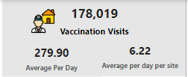
Description:
This visual shows the total visits that are being made to the sites excluding external visits. On the same hand, the second card represents the overall average number of visits that are made on a daily basis. On the contrary, the average number of visits that are made on a daily basis per each site is also being tagged.
DAX / Measure:
total visits + enrollments = calculate(DISTINCTCOUNT(Visits[Visit key]), Visits[visittype] <> "external vaccination")
Average Per Day = 'Measure Table'[total visits + enrollments]/COUNT('Calendar Table'[Date])
Average per day per site = DIVIDE([Average Per Day],calculate(DISTINCTCOUNT(Visits[Location]), all('Calendar Table'[Date])))
Filters:
No filter has been applied.

4. Visual # 4 (New registrations and Scheduled visits)

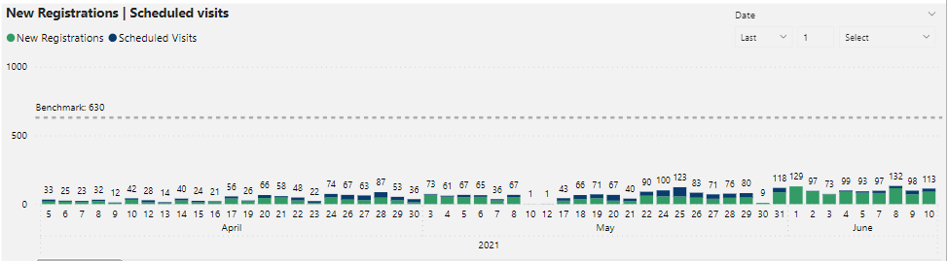
Description:
This visual shows the number of visits that were enrolled for the first time in the system along with their scheduled follow up visits.
DAX / Measure:
Enrollments = CALCULATE(DISTINCTCOUNT(Visits[baseentityid]), Visits[visittype] ="Enrollment",Visits[vaccinesource]="vaccinatoradministered")
Visit = 'Measure Table'[total visits + enrollments] - [Enrollments]
Filters:
No filter has been applied.

5. Visual # 5 (Antigens Administered)
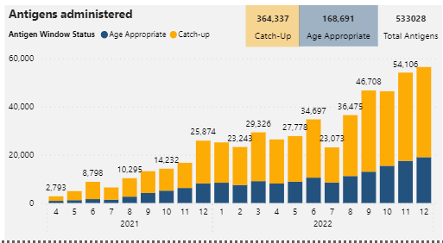

Description:
This visual shows the number of antigens vaccines that are administered every month along with their window status showing the overall breakdown of total antigens.
DAX / Measure:
Total antigens = calculate(DISTINCTCOUNT(Visits[Vacckey]), Visits[visittype] <> "external vaccination")
Catch-up Total antigens = calculate(DISTINCTCOUNT(Visits[Vacckey]), Visits[visittype] <> "external vaccination",Visits[Antigen Window Status]="Catch-up")
Age Appropriate Total antigens = calculate(DISTINCTCOUNT(Visits[Vacckey]), Visits[visittype] <> "external vaccination",Visits[Antigen Window Status]="Age Appropriate")
Filters:
No filter has been applied

6. Visual # 6 (Antigen compliance- Bcg Measles)
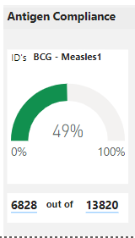

Description:
This visual shows the percentage of children that have been vaccinated with Bcg-Measles1. The compliance percentage is calculated by dividing the figures mentioned above in the cards.
DAX / Measure:
Compliance Rate = DIVIDE(SUM('Compliance Table'[numerator]),SUM('Compliance Table'[denominator]))
bcg-measles1 Compliance Rate = CALCULATE([Compliance Rate],'Compliance Table'[vaccgroup]="bcg-measles1")
Filters:
No filter has been applied.

7. Visual # 7 (Antigen compliance-Penta1-Penta3)
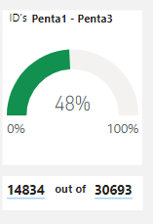
Description:
This visual shows the percentage of children that have been vaccinated with Penta1-Penta3. The compliance percentage is calculated by dividing the figures mentioned above in the cards.
DAX / Measure:
Compliance Rate = DIVIDE(SUM('Compliance Table'[numerator]),SUM('Compliance Table'[denominator]))

penta1-penta3 Compliance Rate = CALCULATE([Compliance Rate],'Compliance Table'[vaccgroup]="penta1-penta3")
Filters:
No filter has been applied.

8. Visual # 8 (Antigen compliance- Measles1-Measles2)
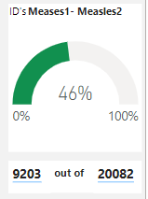
Description:
This visual shows the percentage of children that have been vaccinated with Measles1-Measles2. The compliance percentage is calculated by dividing the figures mentioned above in the cards.
DAX / Measure:
Compliance Rate = DIVIDE(SUM('Compliance Table'[numerator]),SUM('Compliance Table'[denominator]))
measles1-measles2 Compliance Rate = CALCULATE([Compliance Rate],'Compliance Table'[vaccgroup]="measles1-measles2")
Filters:
No filter has been applied.

9. Visual # 9 (Antigen Breakdown)
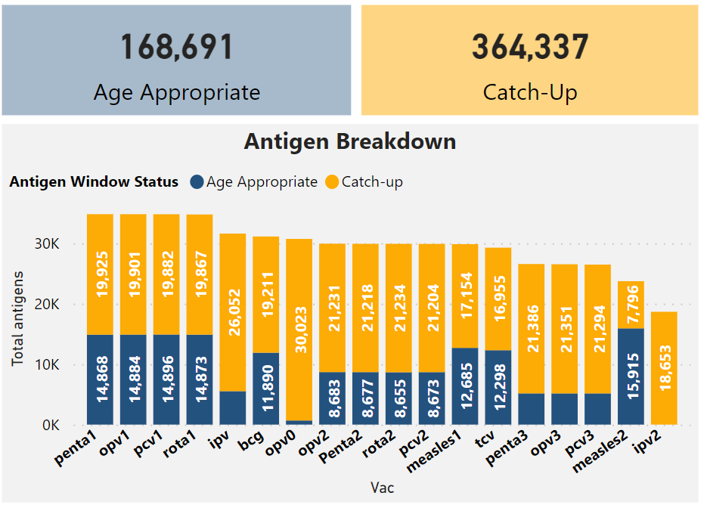
Description:
This visual shows the number of antigens vaccines that are administered along with their window status showing the overall breakdown of total antigens.
DAX / Measure:
Catch-up Total antigens = calculate(DISTINCTCOUNT(Visits[Vacckey]), Visits[visittype] <> "external vaccination",Visits[Antigen Window Status]="Catch-up")
Age Appropriate Total antigens = calculate(DISTINCTCOUNT(Visits[Vacckey]), Visits[visittype] <> "external vaccination",Visits[Antigen Window Status]="Age Appropriate")
Filters:
No filter has been applied.
10. Visual # 10 (Ethnicity)
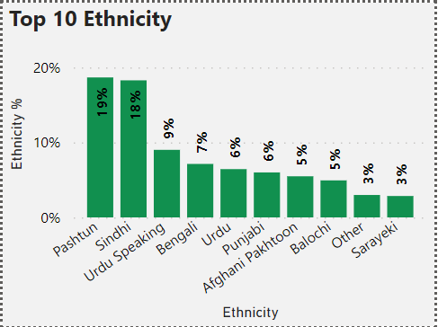
Description:
This visual shows the percentage of children that have been enrolled for the first time in the system on the basis of their ethnicities.
DAX / Measure:
Ethnicity Enrollment = CALCULATE(DISTINCTCOUNT(Visits[baseentityid]), Visits[visittype] = "Enrollment" )
Rank = RANKX(ALL('Visits'[Ethnicity]),[Ethnicity Enrollment],,DESC)
Top N Ethnicity = IF([Rank]<=10,[Ethnicity Enrollment],BLANK())
Filters:
No filter has been applied.
11. Visual # 11 (Gender Breakdown)
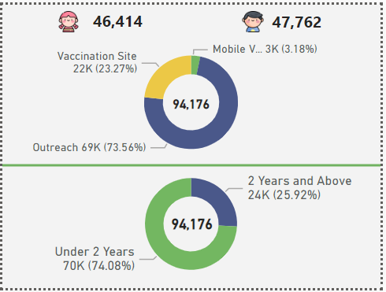
Description:
This visual shows the number of children that have visited for the first time including both the genders. These visits are further divided into ages meaning either falling under the category of Under 2 years or Above 2 years. Also the type of visits are also mentioned which indicates what was the medium through which they got vaccinated.
DAX / Measure:
Boys Enrollments = CALCULATE(DISTINCTCOUNT(Visits[baseentityid]), Visits[visittype] = "Enrollment",Visits[vaccinesource]="vaccinatoradministered",(Visits[Gender]="male" || Visits[Gender]=BLANK()))
Girls Enrollments = CALCULATE(DISTINCTCOUNT(Visits[baseentityid]), Visits[visittype] = "Enrollment",Visits[vaccinesource]="vaccinatoradministered",Visits[Gender]="female")
Enrollments = CALCULATE(DISTINCTCOUNT(Visits[baseentityid]), Visits[visittype] = "Enrollment",Visits[vaccinesource]="vaccinatoradministered")
Filters:
Four filters have been applied.
- Age distribution is not blank
- Vaccine status is not blank
- Gender is not Not Applicable
- Date is after 4 April,2021

12. Visual # 12 (Count of vrid-Bcg-Measles1)
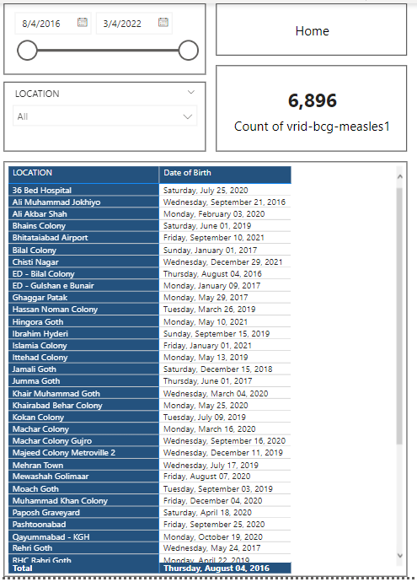
Description:
This visual shows the number of non-compliance id against every location specifically for vaccination of
Bcg-Measles1.
DAX / Measure:
Count of vrid-bcg-measles1 = CALCULATE(COUNT('Compliance Table-Non-compliance VRIDs'[vrid]),'Compliance Table-Non-compliance VRIDs'[vaccgroup]="bcg-measles1")
Filters:
Vacc Group is bcg-measles1
13. Visual # 13 (Count of vrid Penta1-Penta3)
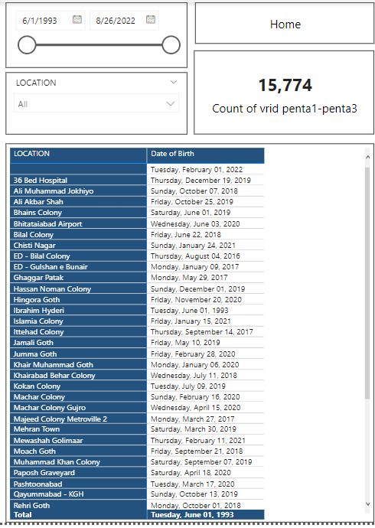
Description:
This visual shows the number of non-compliance id against every location specifically for vaccination of
Penta1-Penta3.
DAX / Measure:
Count of vrid penta1-penta3 = CALCULATE(COUNT('Compliance Table-Non-compliance VRIDs'[vrid]),'Compliance Table-Non-compliance VRIDs'[vaccgroup]="penta1-penta3")
Filters:
Vacc group is Penta1-Penta3.
14. Visual # 14 (Count of vrid-Measles1-Measles2)
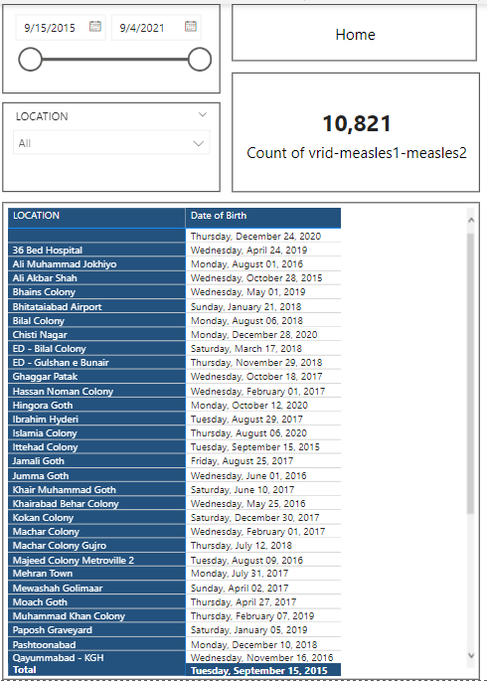
Description:
This visual shows the number of non-compliance id against every location specifically for vaccination of
Measles1-Measles2.
DAX / Measure:
Count of vrid-measles1-measles2 = CALCULATE(COUNT('Compliance Table-Non-compliance VRIDs'[vrid]),'Compliance Table-Non-compliance VRIDs'[vaccgroup]="measles1-measles2")
Filters:
Vacc group is Measles1-Measles2

